*Florida International University*

*School of Computing and Information Sciences*

CIS 4911 - Senior Capstone Project

Software Engineering Focus

Feature Document

User Story # 632

**Team Member:**

Garrett Lemieux

**Product Owner(s)**:

Francisco Ortega

**Mentor(s)**:

Francisco Ortega

**Instructor**: Masoud Sadjadi

**User Story - Implement Radial menu for Interactive UI**

* As user I would like to change modes in Interactive UI in order to allow for intuitive and effective interaction with Interactive Paint Program.
* Acceptance Criteria:

1. Implement Radial menu that will allow for different modes to appear and be selected.
2. Provide feedback to user on mode being selected.

**Use Case: User changes setting using radial menu**

User wants to be able to change draw settings using a radial menu using the multitouch screen.

* Details:
* Actor:
  + User
* Pre-conditions:
  + TouchPoint app is running.
  + Multi Touch Acer screen connected.
* Description:
  + Use case begins when User has decided to change the current drawing setting related to size, color, symmetry line, or UI display.
  + User double taps location he or she wants radial menu to be displayed.
  + User than can selected one of four buttons on radial menu.
  + Use case ends once the user decided he or she has finished altering current setting and presses center button of radial menu to disable or exit menu.
* Post-conditions:
  + The desired change in setting should have occurred with feedback and the radial button should no longer be displayed or active.
* Alternative Courses of Action:
  + User can change current color by selecting left radial button.
  + User can change current shape by selecting right radial button.
  + User can toggle on and off symmetry mode by selecting top radial button.
  + User can toggle on and off UI display by selecting bottom radial button.
  + User can exit radial menu by selecting center radial button.
* Decision Support:
  + Frequency: High, User will need to change his or her setting and view current settings on a regular basis.
  + Criticality: High, Allows Users a more efficient and direct way to change current setting.
  + Risk: Medium, Needed to figure out how to implement buttons with touch screen.
* Usability:
  + Need to be able to read user guide and follow instructions.
  + Understand different drawing settings.
* Reliability
  + High
* Performance
  + Performance High , low failure
* Supportability
  + Multi-touch Screen (ACER)
* Modification History:
  + Owner: Garrett Lemieux
  + Initiation Date 3/8/2016
  + Date last Modified: 5/5/2016

**Use Case Diagram**

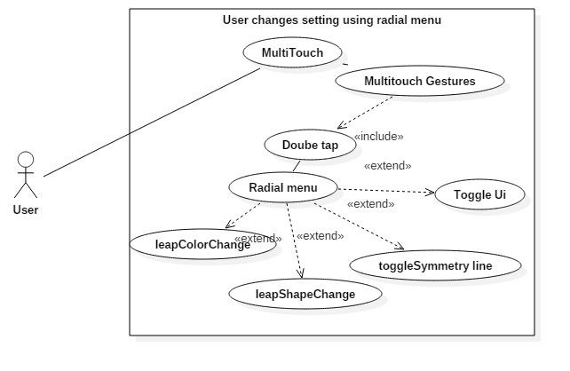

**Sequence Diagram**

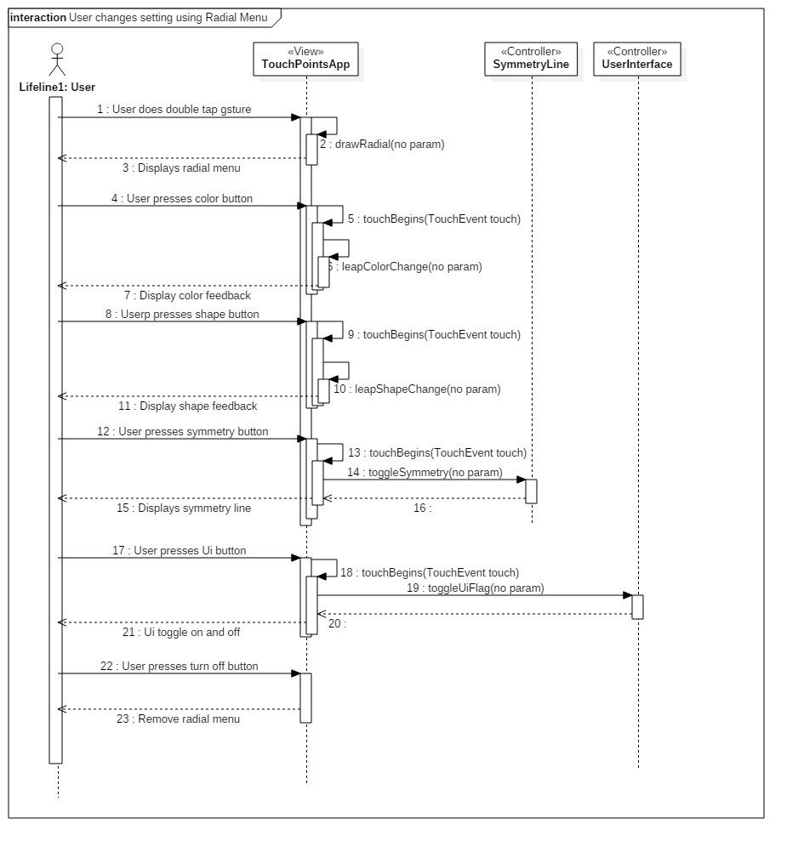

**Class Diagram**

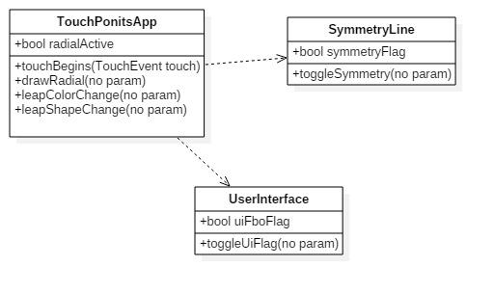

**Unit Test**

* Sunny Day Test:
  + Test Case  - Enable Radial Menu
    - Test Purpose: To determine if user can pull up radial menu dynamically.
    - Test Procedure: User double taps location he or she wants radial  menu to appear.
    - Expected Results: Radial menu appears in desired location.
  + Test Case  - Change Color
    - Test Purpose: To change the current color being used to draw.
    - Test Procedure: User presses left button within radial menu.
    - Expected Results: The color updated in the Ui display and feedback provided to user.
  + Test Case  - Change Shape
    - Test Purpose: To change the current shape being used to draw.
    - Test Procedure: User presses right button within radial menu.
    - Expected Results: The shape updated in the Ui display and feedback provided to user.
  + Test Case  - Toggle Symmetry Line
    - Test Purpose: To determine if user can toggle symmetry mode on and off.
    - Test Procedure: User presses top button within radial menu.
    - Expected Results: If symmetry mode is on then it should turn off and if symmetry mode is off it should be turned on.
  + Test Case  - Toggle Ui Display
    - Test Purpose: To determine if user can toggle ui display on and off.
    - Test Procedure: User presses bottom button within radial menu.
    - Expected Results: If Ui display is on then it should turn off and if Ui display is off it should be turned on.
  + Test Case  - Disable Radial Menu
    - Test Purpose: To determine if user can turn radial menu on and off.
    - Test Procedure: User presses middle button within radial menu.
    - Expected Results: Radial menu will be removed from screen.
* Rainy Day Test:
  + Test Case  - User Presses Area between buttons
    - Test Purpose: Test  if radial menu functions correctly if user presses area between buttons within radial menu.
    - Test Procedure: User tries to press left button and misses button
    - Expected Results: No change in current states is expected. If change observed test failed.
  + Test Case  - User Presses Area Outside of Radial menu
    - Test Purpose: Test if radial menu buttons only work within radial menu
    - Test Procedure: User presses any area just outside of radial menu.
    - Expected Results: User should observe that area being drawn. If any state changed then test failed.

**Integration Testing**

* The ability to use the radial menu while all devices are connected is successful. User may use radial menu only with multi touch screen but can still have full functionality after setting has changed with leap motion and real sense devices.
* All previous functionality of TouchsPointsApp work correctly while radial menu is enabled and any update made with radial menu is observed by entire application.

**User Guide**

* User must first double tap the screen in locatio he or she would like radial menu to appear.

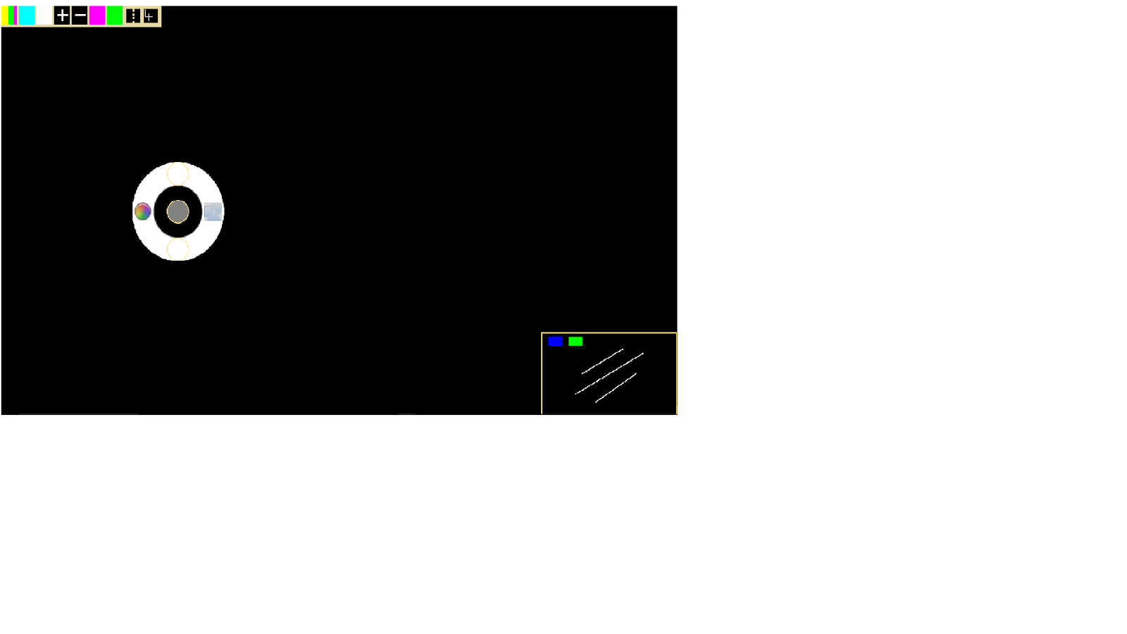

* Once radial menu has appeared user has options to select 5 different buttons which can be selected by simply tapping the button.
* Left button - Changes current color being drawn.
* Right button - Changes current shape being drawn.
* Top button - Toggles symmetry line on and off.
* Bottom button - Toggles Ui display on and off.
* Middle button - Removes radial menu.

**Glossary**

Radial menu - is also known as a pie menu and uses a circular context for the menu. Selection is dependent on direction.